Waveform Generation:
Any signal detected by the photodiode will inevitably contain elements resulting from ambient light sources. Most of these signal components will have frequencies around 100Hz. In order to limit the effect that these ambient sources would have on any readings taken, it was decided that a high frequency signal should be applied to the LED’s. The ambient signals could then be removed by high-pass filtering the output from the photodiode. The frequency of the waveform applied to the LED’s was limited primarily by the response time of the photodiode. With a combined rise and fall time of 80μs, it would not be capable of detecting any signals greater than about 12kHz. With this in mind, a frequency of 10kHz was decided on for the LED signal. Generating this signal is quite easily implemented in assembly. By setting up a loop which will take 50μs to execute, and complementing one of the output pins at the beginning of each loop, a 10kHz square wave results. An alternative to using this code to produce a square wave would be to use the wave generator provided on the board.

Sampling Photodiode Output:
The Analogue-to-Digital Converter on the AduC812 has two primary modes of operation, namely single and continuous conversion. In single conversion mode, as the name suggests, one conversion is performed whenever the ADC is instructed to do so. In continuous conversion mode, the ADC interrupt is enabled, and the ADC performs conversions at regular intervals determined by the acquisition and conversion times. While continuous mode seemed more appropriate for collecting a series of samples from the input signal, this mode would make it far more difficult to control the waveform being produced to control the LED’s. In this mode, the loop controlling the generation of the square wave being output to the LED’s would be interrupted every sample period (≈ 6μs). This would make the control of the square wave’s frequency and duty cycle very difficult.
The generation of a square wave and the sampling of the photodiode output were thus combined into one problem. The frequency of the square wave was determined by the length of time taken to convert a certain number of samples in single conversion mode. This is illustrated below:
Complement LED
Convert 3 samples
YES
Enough samples taken?
Finish

NO

This loop, when implemented, takes approximately 54μs to execute, giving a square wave frequency of ≈ 9.2kHz, which is acceptable for our purposes.

Filtering:
Although it is quite possible to implement a filter for this application using discrete components, this would introduce more noise to the input to the ADC. It was therefor decided that a digital filter would be a more appropriate choice. The transfer function of the filter used in is:
H(z) = 1 + z⁻¹ .
1 + 0.892z⁻¹
The difference equation is:
y(n) = x(n) – x(n-1) + 0.892y(n-1)
This is a first order filter with a corner frequency of 1kHz. The sampling rate is about 55.2kHz (9.2kHz x 6). Although a higher order filter could be used, it would be more difficult to encode, and the execution of the program would become considerably slower. For simplicity, 0.892 is rounded up to 0.9. It is obviously not possible to multiply by decimals in assembly, so the alternative used is to multiply the y(n-1) term by 9, and then divide by 10. The inaccuracy involved is negligible (≈ 0.02%).
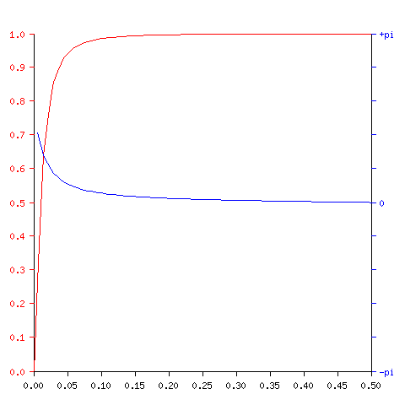
The normalised magnitude (red) and phase (blue) responses of the filter are shown:

Quantization and Colour Space:
The number of quantization levels for each of the red, green and blue components determines the number of colours in the colour space. For example, if five different quantization levels are assumed for each component, as is the case in our application, then a total of 125 different colours may be recognised. Assuming that the inputs to the ADC are in the range 0 – 2.5V, then the five quantization levels are 0V, 0.625V, 1.25V, 1.875V and 2.5V.
It is not necessary for each component to have the same number of quantization levels. It may be desired that the colour space be more sensitive to red hues than greens for example. In this case, it may be more suitable to allow six quantization levels for red and three for green. The number of quantization levels and therefor the total number of colours distinguishable is limited by memory space.
Once each component has been assigned a quantization level, all that remains is for the colour with matching RGB components to be located in the colour space. This is done by setting up a loop to cycle through the total number of possible colours in the colour space and comparing their RGB components to those measured. Once a match is found, the address of this colour in the chipcorder memory is output.

